 | Press Release

Embellishment – a contribution to the success of your customer

Different embellishment options, like multi-foiling or 3D spatial images, allow brand owners to create distinguished labels, which help products to win the battle on the shelf. Pantec offers a complete portfolio of rotary and flat-bed embellishment systems for short and long runs.

Kradolf / Switzerland – September 19, 2019 – It is a growing challenge for brand owners to win the attention of the consumers. The label on a product plays an important role to win the attention of the consumer – and hence the battle on the shelf.
René Abächerli, Head of Sales at Pantec, sees a significant trend in the market: “Simple hot-foiling or embossing have been a common embellishment features for high value products, like wine and spirits, for many years. The expectation of the brand owner in this segment has continuously risen over the last years.” Multi-foiling, high relief 3D embossing or the combination of fine lines with large foiling areas are frequently in demand. Any label printer, who is targeting the wine and spirits segment must be able to offer these embellishment options. However, the label printer has to be able to offer this kind of embellishment at minimal cost, in order to be successful. To do so, he needs dedicated embellishment systems that don’t slow down the printing process and that save as much foil as possible.”
Brand owners in the segment of FMCG, like body care products, have a growing interest to find new, cost-effective design features to make their products stand out on the shelf. Beside the well- established cold foiling, there are now highly interesting new options available on the market – like 3D single images or lenses – to attract the attention of consumers.

For René Abächerli, productivity and efficiency are a critical success factor: “The success of a label printer in the market segment of embellished labels depends to a high degree on the equipment used. Pantec shows – at the Labelexpo Europe – embellishment systems that offer high productivity and save up to 95% of foil.“
SWIFT – Rotary system to place 3D spatial images or lenses
The SWIFT is a rotary system used to place 3D spatial images or lenses onto the label. It replaces the unwind and rewind of a conventional hot foil unit. The combination of the Pantec vacuum technology and the use of the latest servo technology with the highest dynamics enables the SWIFT to place up to 20 single images per second. This results in a web speed of up to 120 m/min., depending on the design of the label. Placing every single image individually means, that the foil can be fully utilized with basically no waste at all. The SWIFT technology can also be used to save up to 95% of standard hot foil.
The SWIFT technology can also be used to apply 3D spatial images to shrinks sleeves.
RHINO – Flatbed hot-foil embossing system
The flatbed hot-foil embossing system RHINO is already well established in the market for wine and spirit labels. The growing demand for shorter runs require flatbed embellishment system with specific design features. Web speed or stroke frequency are not so critical, whereas an easy and fast tool change will be highly beneficial. With the launch of the new RHINO E, Pantec offers an embellishment system based on the well-established RHINO technology, but designed with shorter runs in mind.
The new RHINO E – designed for short runs
By restricting the stroke frequency to 18’000 per hour, it was possible to build the
RHINO E lighter and leaner. This stroke frequency still allows a web speed of up to 85 m/min, depending on the design – a speed well accepted for short runs.

The tooling cassette of the RHINO E has been designed to accommodate frequent tool changes typically for short runs. There is no need to cut the foil or the substrate when changing the tooling, regardless of whether just a simple flat hot foiling or a more complex embossing tools are being used.

The RHINO E still has the option to foil across the web, which opens up the opportunity to do complex multi-foiling designs often required for high value products. In addition, the RHINO E can be equipped with two foil levels to maximize the foil saving, because the foils can be advanced in different steps.

An intuitive, user-friendly HMI makes it easy for the operator to run the RHINO E. Beside the normal job data setting and storing, it calculates the optimal foil saving based on the design parameters of the label.

René Abächerli is pleased about the positive reactions from the market: “With the launch of the RHINO E, Pantec is complementing its RHINO Product Portfolio, to give the label industry the answer for the growing demand for short runs of highly embellished labels. The RHINO E is also perfectly suited for label printers, who have to add embellishment capabilities to their offerings. This embellishment could make the difference for the product between being picked up on the shelf or being ignored by the consumer.”

Footage
All material can be downloaded at pantec-gs.com/en/labelexpo2019

RHINO-series
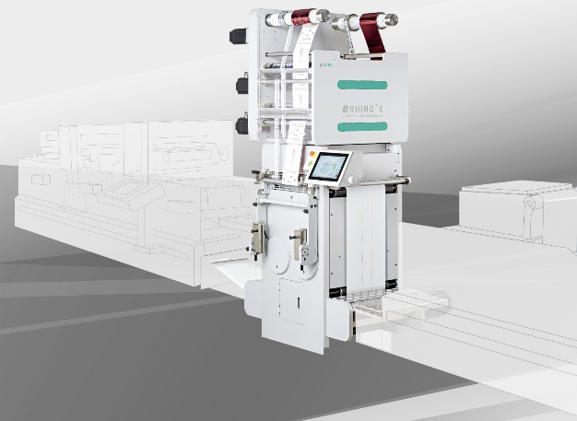  The new RHINO E enables efficient high quality embellishment for short jobs  The new RHINO E is best suited where running speed is not paramount, yet high quality embellished labels are still required. | 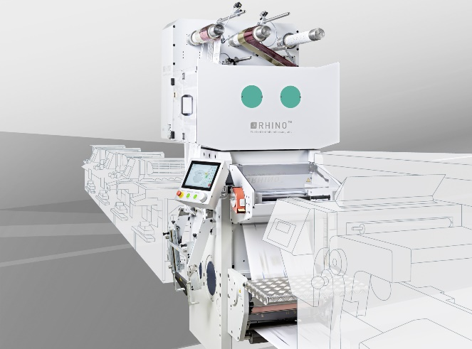  The RHINO S with its 30‘000 strokes per hour is fully capable of operating in-line to printing presses dedicated to labels of high degree of embellishment
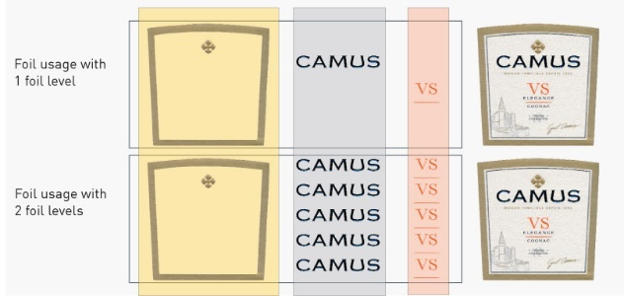  The two foil level system of the RHINO series saves more foil than any other system on the market. | 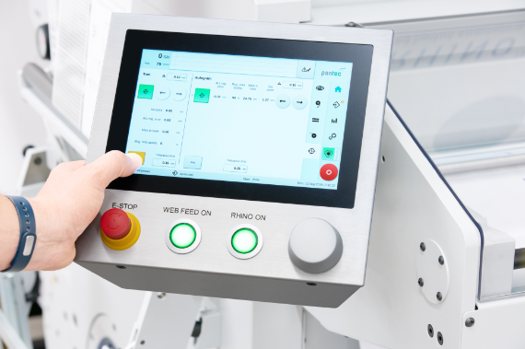  Designed for ease of use: An intuitive, user-friendly HMI makes it easier for the operator to run RHINO.
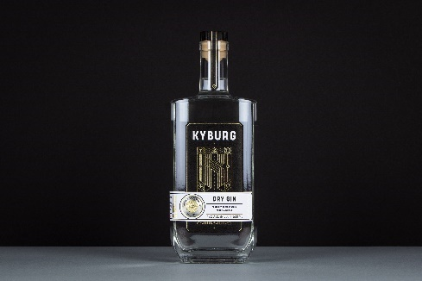  Gin Kyburg: A modern spirituous design with exclusiveness, made by Pantec RHINO E | 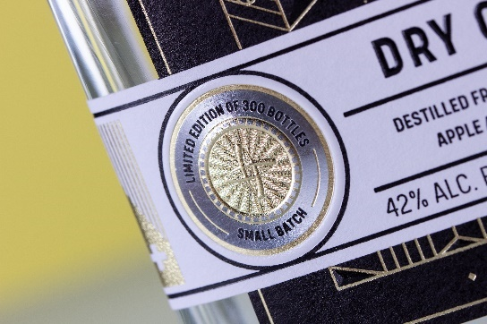  A security patch with foil embossing in 3 steps by RHINO E makes Gin Kyburg a real eye-catcher
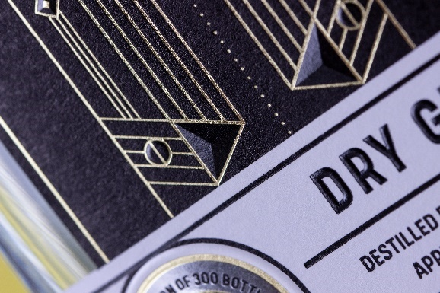  Many fine details and 3D embossings make Gin Kyburg a real eye-catcher. | 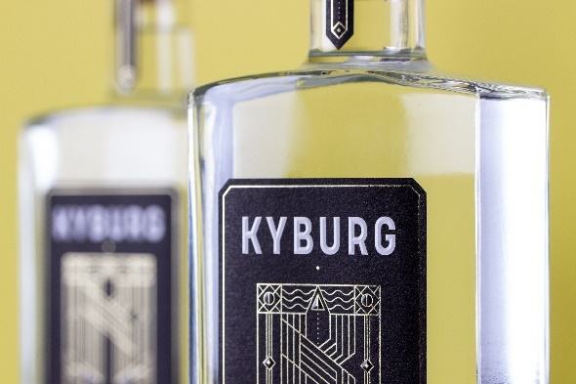  Many fine details and 3D embossings make Gin Kyburg a real eye-catcher.
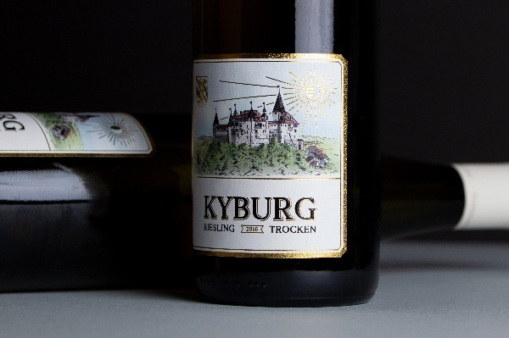  Riesling Kyburg: a elegant, traditional and exclusive wine label, made on Pantec RHINO E | 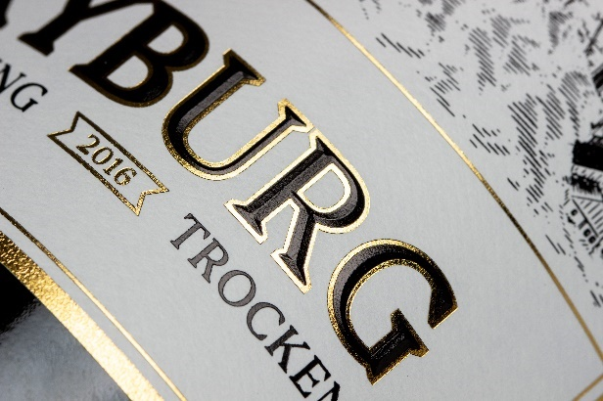  Illustrative design in combination with elegant typography and noble patterns make Riesling Kyburg a real eye-catcher
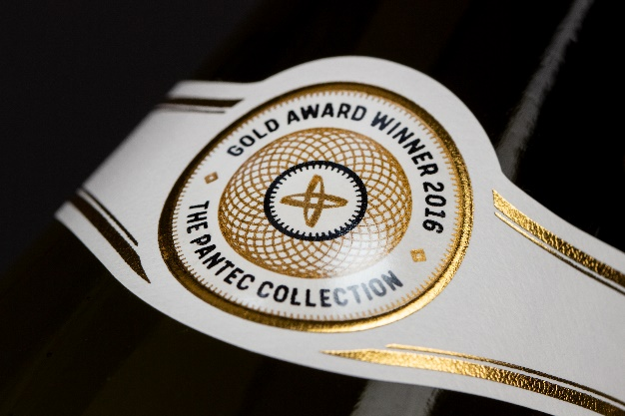  A transparent holo lens, placed in register by RHINO E, makes Riesling Kyburg a real eye catcher | 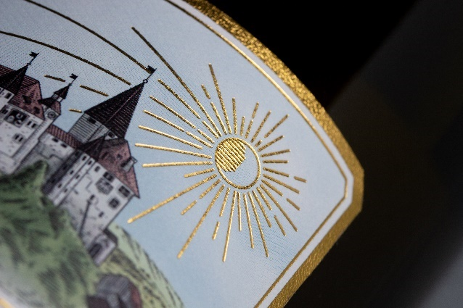  Illustrative design in combination with elegant typography and noble patterns make Riesling Kyburg a real eye-catcher

SWIFT-series
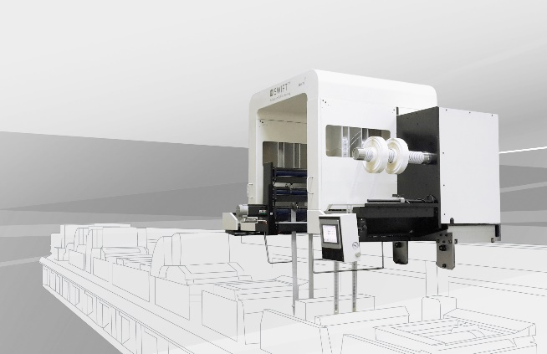  The high performance of Pantec SWIFT enables the cost-effective application of registered foils and opens up new embellishment possibilities for fast moving consumer goods | 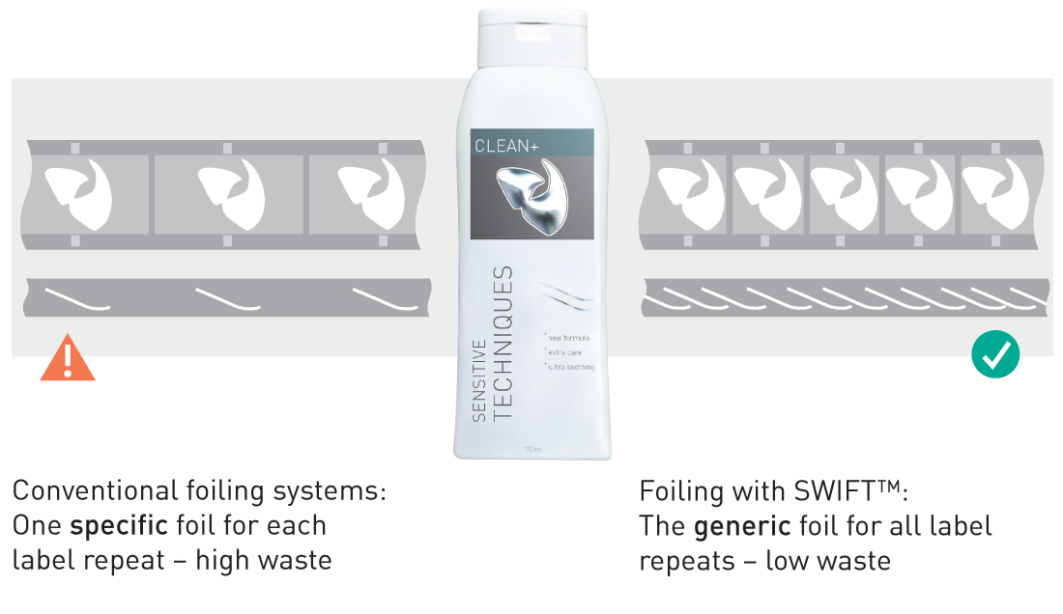  Pantec SWIFT moves and places each foil image individually in register. Therefore the same foil can be used for any label repeat.
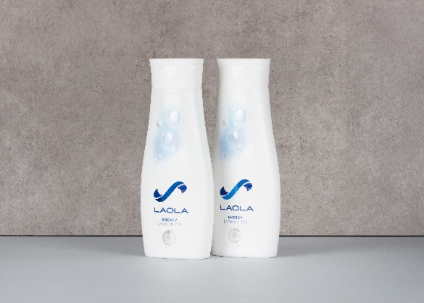  Laola Body Care: the high-quality eyecatcher on the shop shelf, label refined with Pantec SWIFT™ | 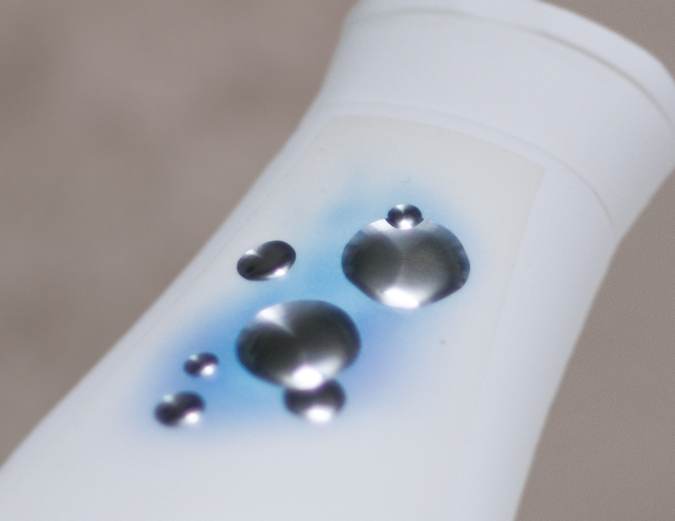  Pantec SWIFT places up to 20 images – e.g. a Kurz Trustseal - per second. Each image is placed individual, therefore the expensive image roll is completely used after a job

About Pantec GS Systems

Pantec Print Decoration provides sophisticated refining solutions. Our dedicated equipment for rotary and flat bed hot foil stamping & embossing, high performance vacuum foil savers and high speed & precision hologram placement is made to provide efficient high quality refining, directly in-line. Pantec Print Decoration is an independent subsidiary of Pantec AG, a worldwide operating technology supplier for industrial applications and medical devices offering services, products and solutions in the field of machinery and medical engineering.

For publishing questions:

Pantec GS Systems AG
René Abächerli
Head of Sales
Heldswilerstrasse 13
CH-9214 Kradolf
Phone +41 71 5210 808
Email rene.abaecherli@pantec.com
www.pantec-gs.com

